**Installation of VS Code:**

**Steps to Download and Install Visual Studio Code on Windows 11:**

1. **Download:**
   * Go to the official Visual Studio Code website: <https://code.visualstudio.com/>

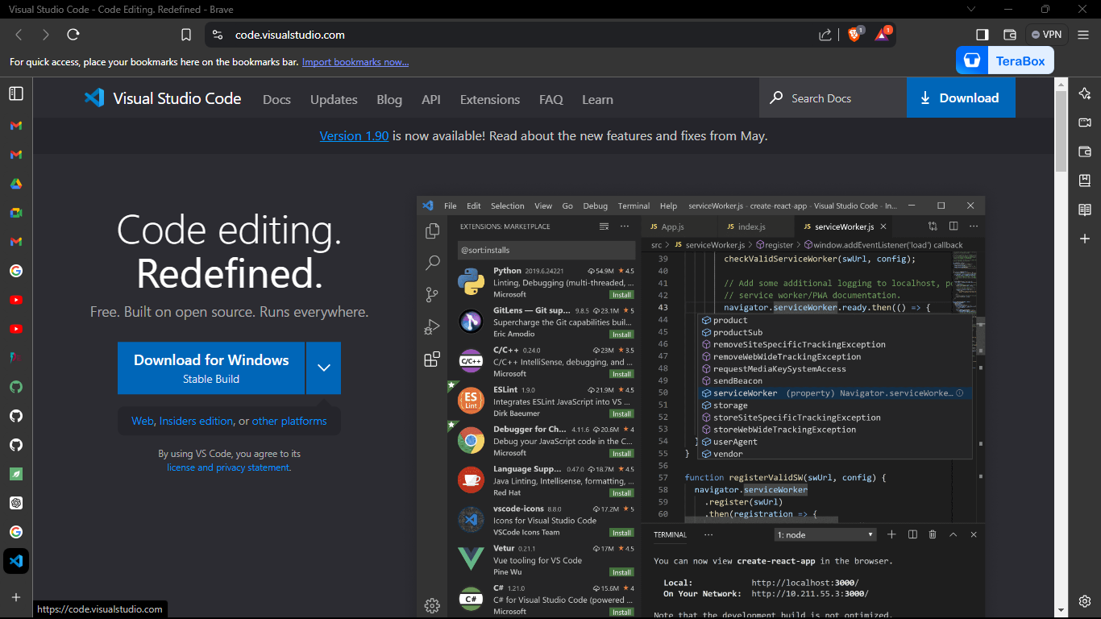

* + Click on the "Download for Windows" button.

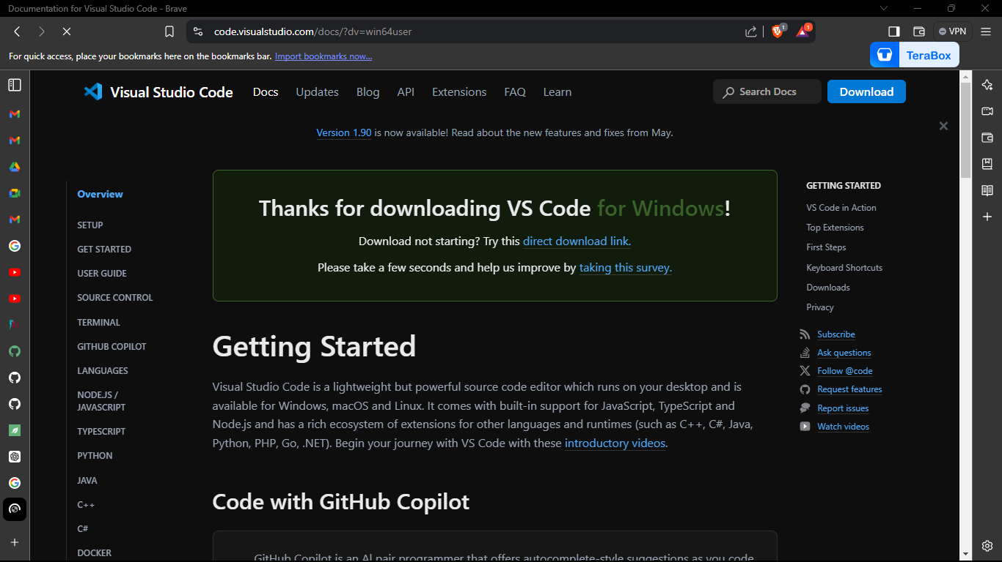

* + Once the download is complete, open the downloaded installer.

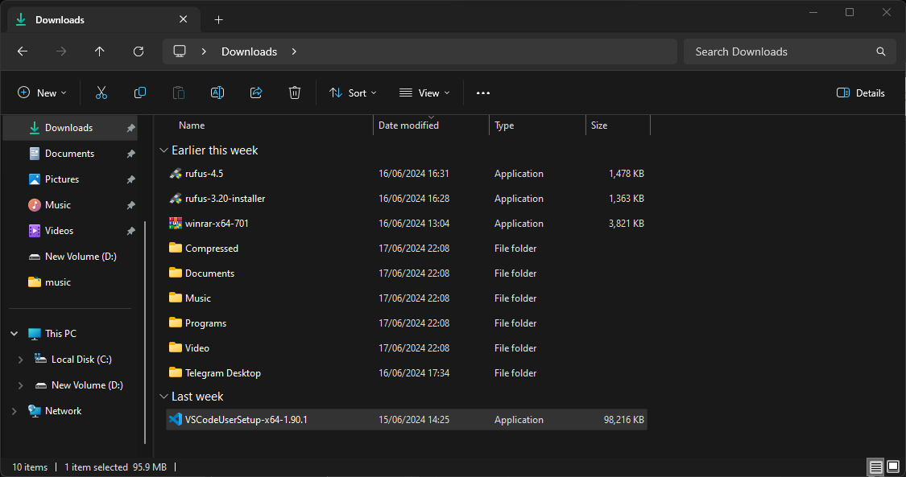

1. **Installation:**
   * Run the installer by double-clicking the downloaded file (**VSCodeSetup.exe**).

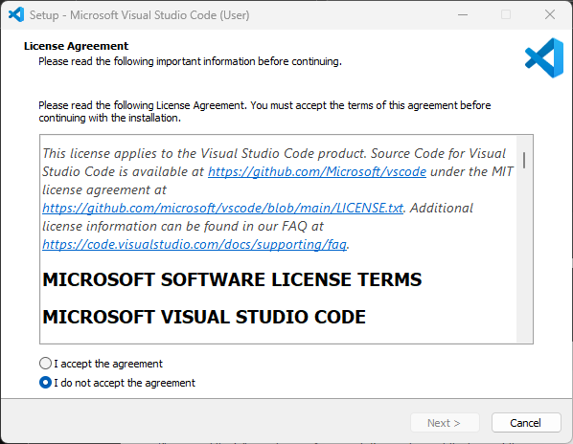

* + Accept the license agreement and click "Next".

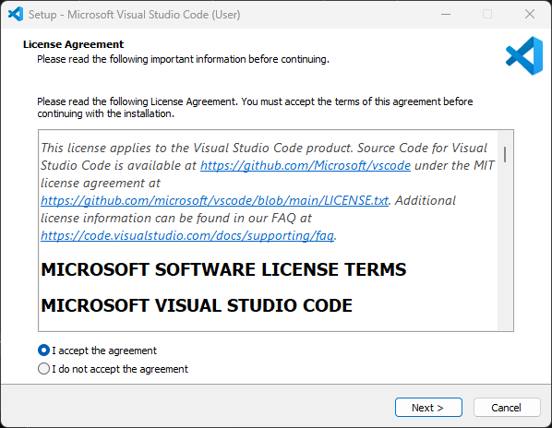

* + Choose the destination folder for installation and click "Next".

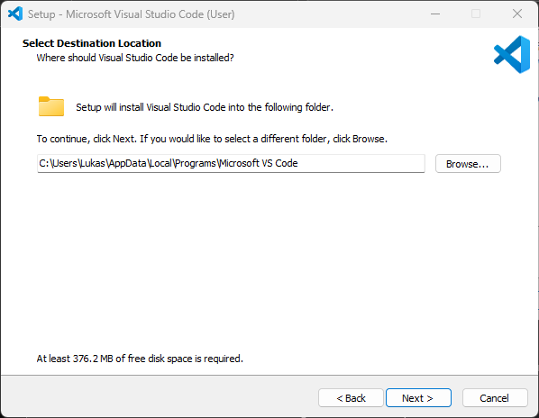

* + Select additional tasks such as creating a desktop icon and adding VS Code to the system PATH, then click "Next".

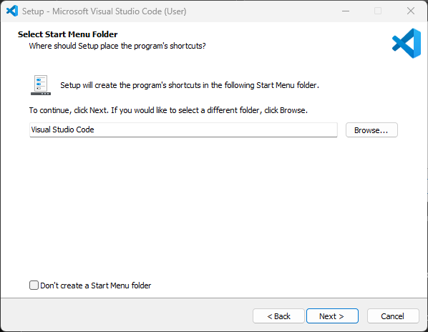

* + Click "Install" to begin the installation process.

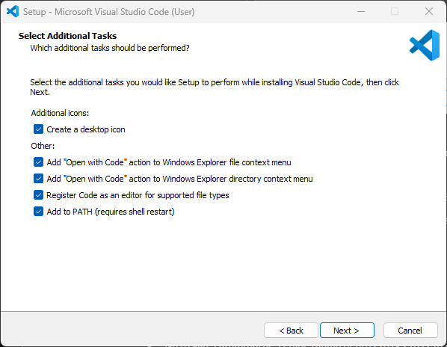

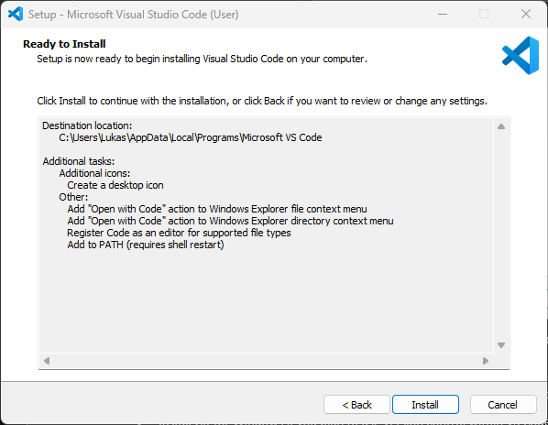

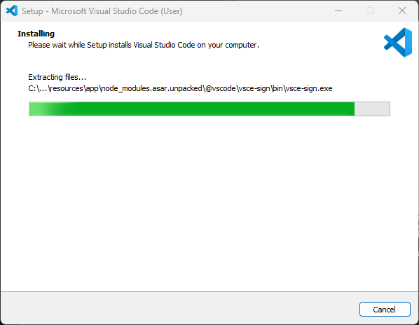

* + Once the installation is complete, click "Finish" to launch VS Code.

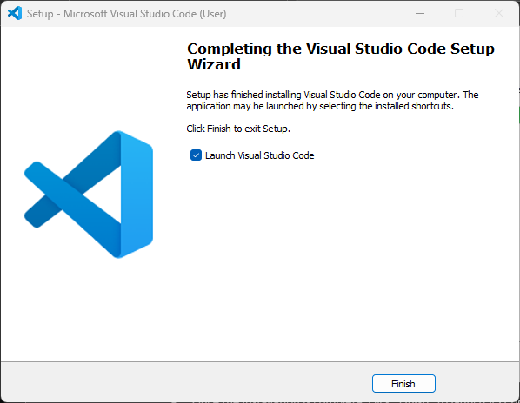

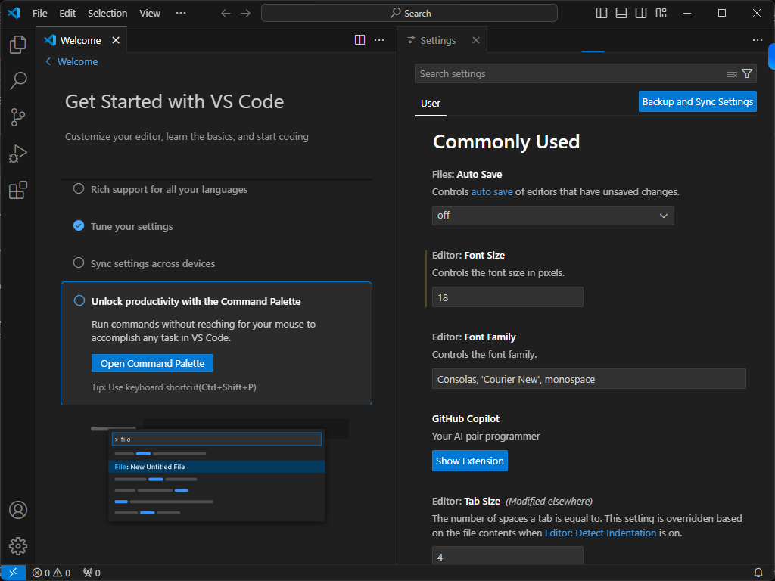

**First-time Setup:**

**Initial Configurations and Settings:**

1. **Theme and Appearance:**
   * Open VS Code.
   * Go to **File > Preferences > Color Theme** or use **Ctrl+K Ctrl+T** to choose a theme.

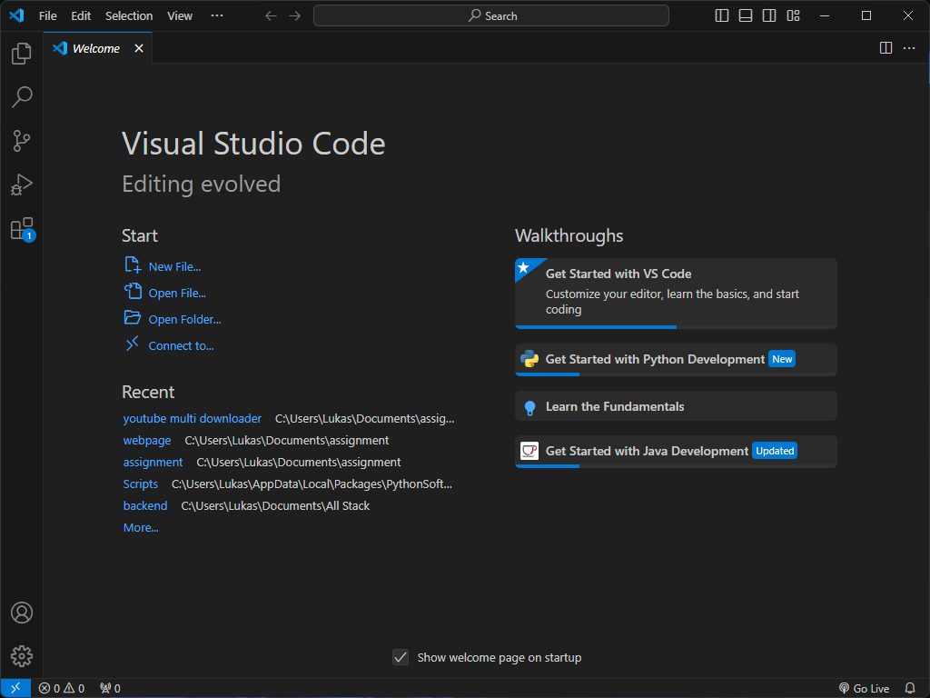



1. **Extensions:**
   * Click on the Extensions icon in the Activity Bar or use **Ctrl+Shift+X**.
   * Search and install essential extensions such as:
     + **Prettier - Code formatter** for code formatting.

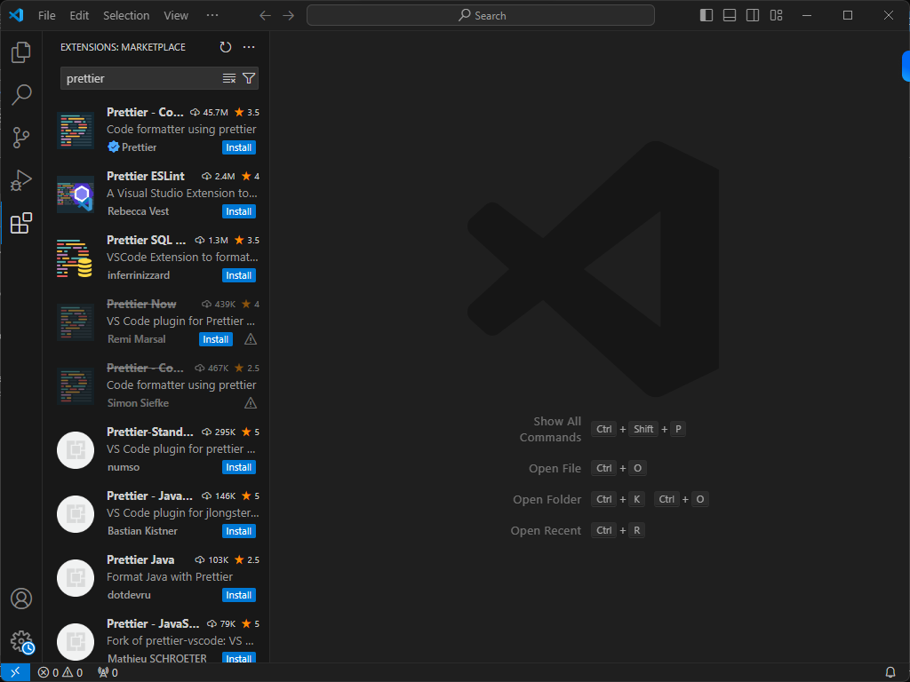

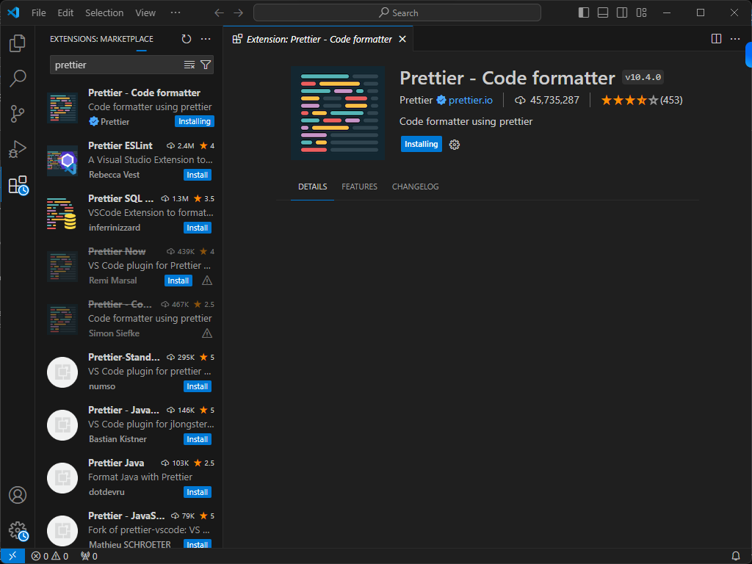

* + - **Live Server** for launching a local development server with live reload.

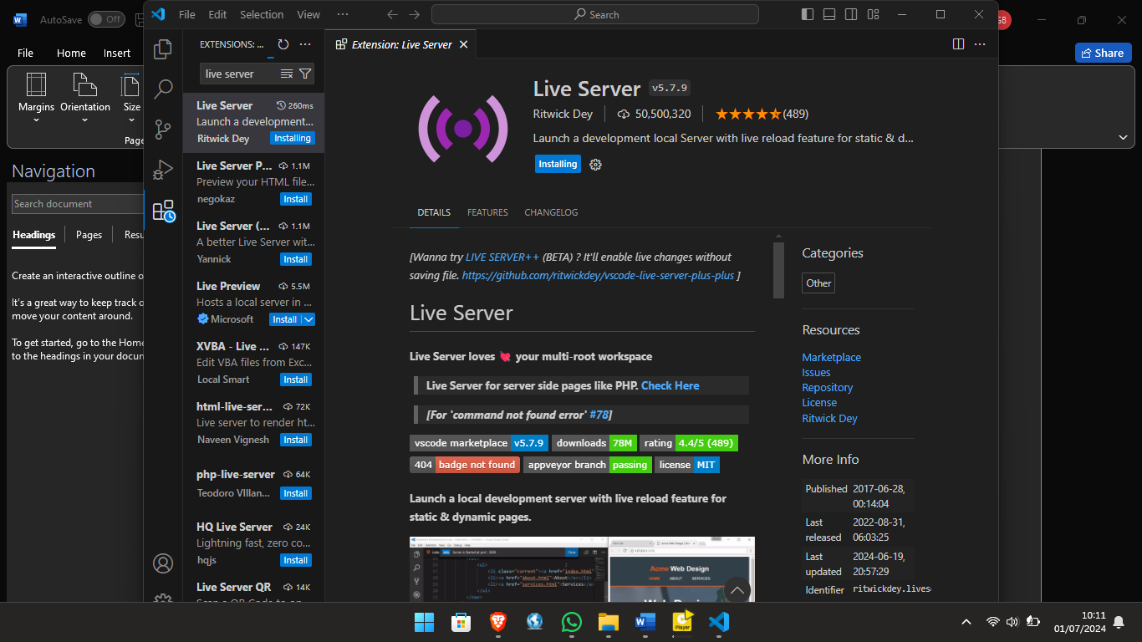

1. **Settings:**
   * Go to **File > Preferences > Settings** or use **Ctrl+,** .

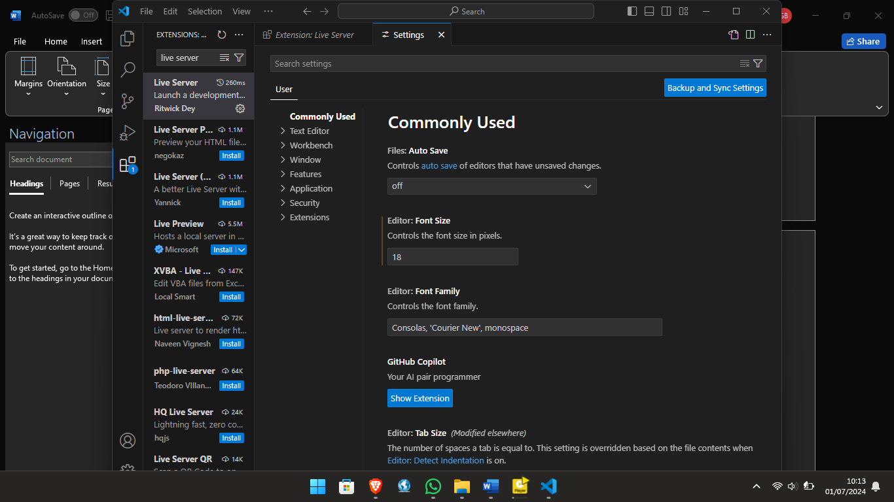

* + Adjust settings such as font size, tab size, auto-save, etc.



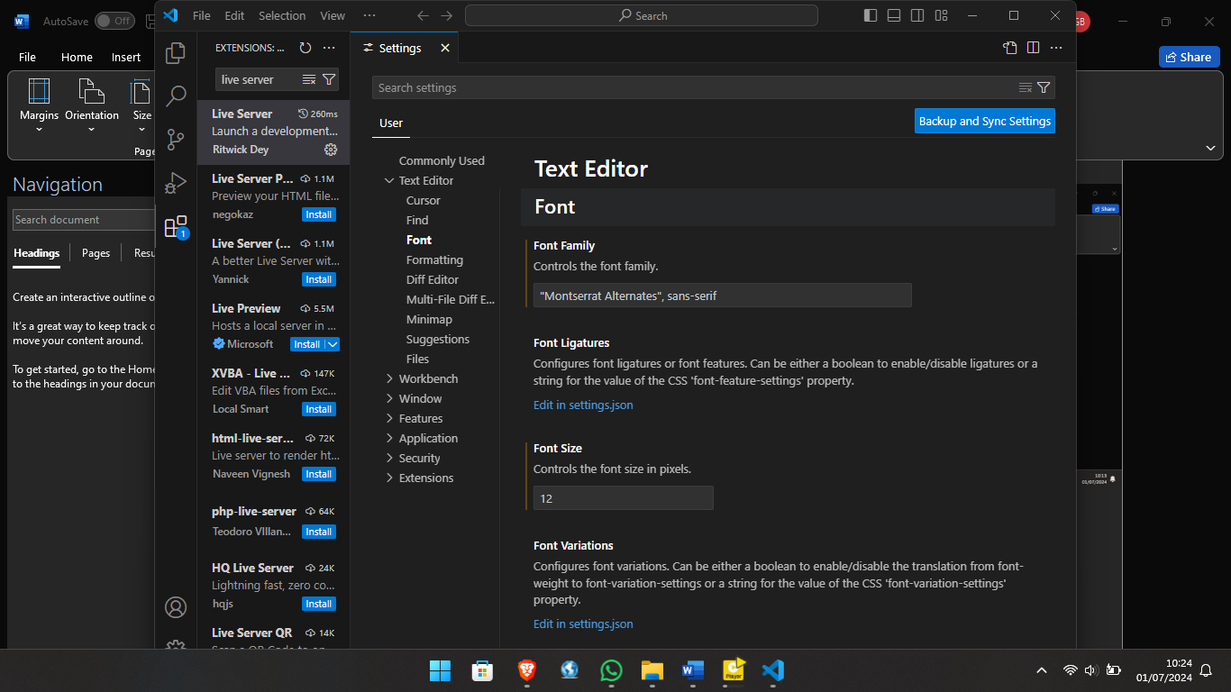

**User Interface Overview:**

**Main Components of the VS Code User Interface:**

1. **Activity Bar:**
   * Located on the far left of the window.
   * Provides quick access to different views such as Explorer, Search, Source Control, Run and Debug, and Extensions.

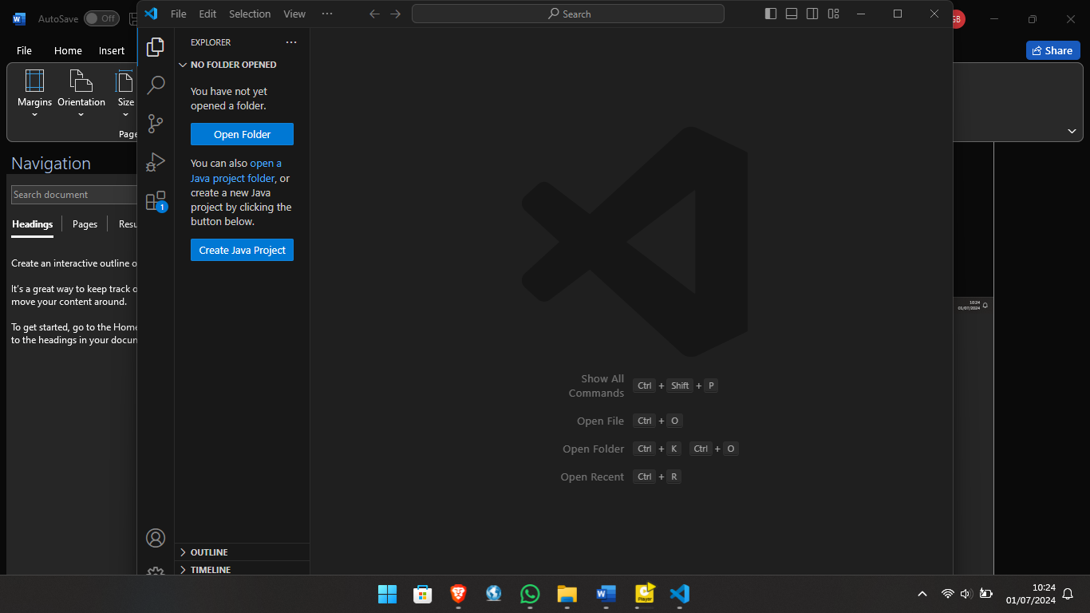

Explorer

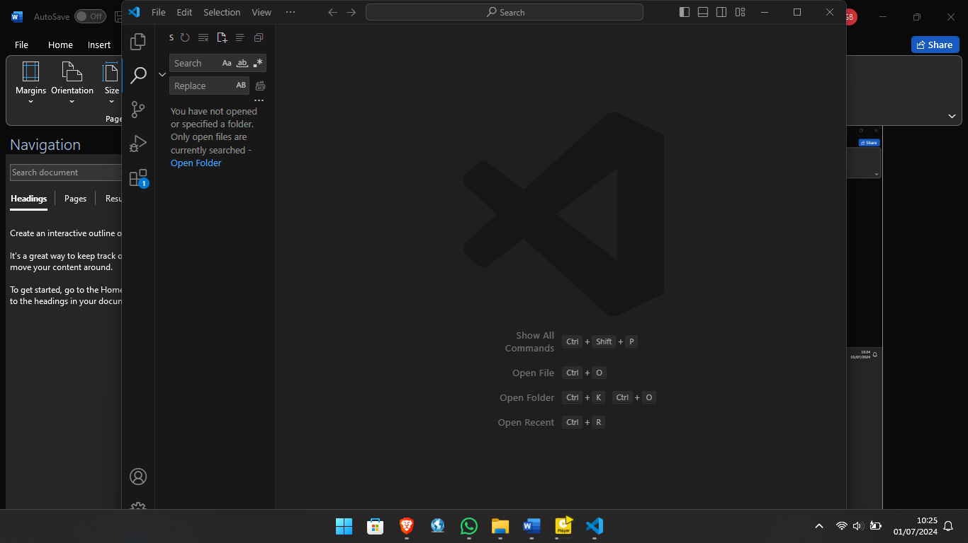

Search

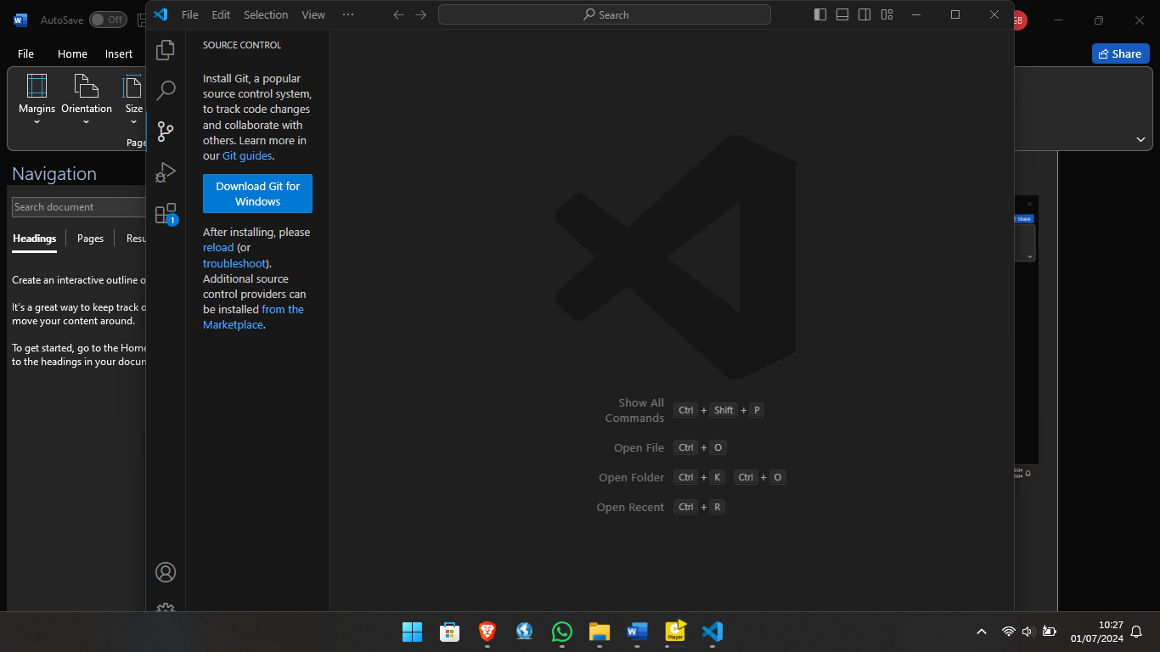

Source Control

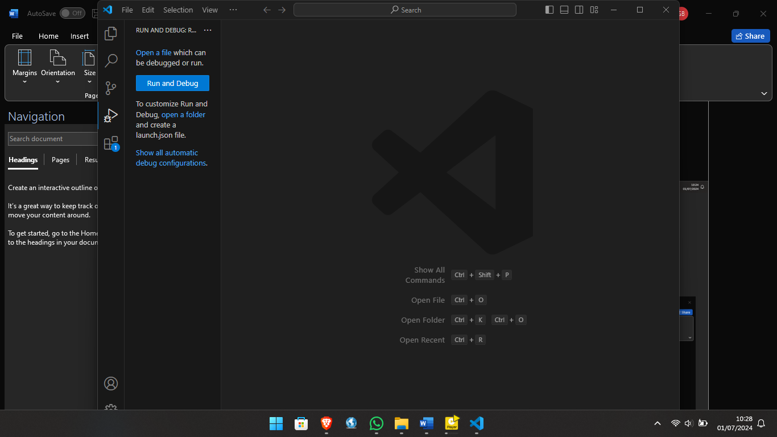

Run and Debug

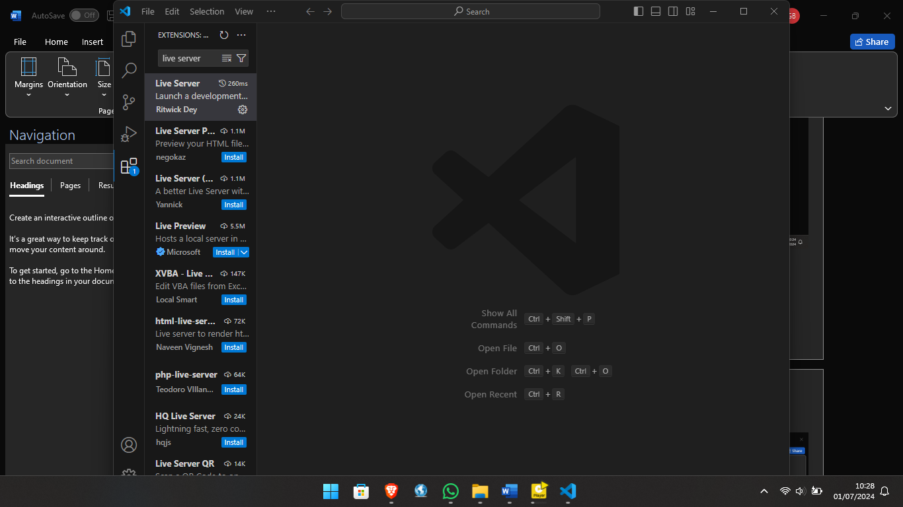

Extensions

1. **Side Bar:**
   * Displays different views and panels based on the selection from the Activity Bar.
   * Commonly used to show the Explorer, Source Control, and Extensions views.
2. **Editor Group:**
   * The main area where files are opened and edited.
   * Supports multiple tabs and split views for side-by-side editing.
3. **Status Bar:**
   * Located at the bottom of the window.
   * Displays information about the current file and workspace, such as encoding, line endings, language mode, and more.
   * Provides shortcuts to manage various settings and extensions.

**Command Palette:**

**What is the Command Palette and How to Access It:**

* The Command Palette is a powerful feature that allows you to access and run commands quickly.
* Access it by pressing **Ctrl+Shift+P** or **F1**.
* Examples of common tasks:
  + Open a file: **Ctrl+P**.
  + Change the color theme: Type **>Theme: Change Color Theme**.
  + Install extensions: Type **>Extensions: Install Extensions**.

**Extensions in VS Code:**

**Role of Extensions and How to Manage Them:**

1. **Role:**
   * Extensions enhance the functionality of VS Code by adding support for new languages, themes, debuggers, and tools.
2. **Finding and Installing Extensions:**
   * Click on the Extensions icon in the Activity Bar or use **Ctrl+Shift+X**.
   * Search for the desired extension and click **Install**.
3. **Managing Extensions:**
   * View installed extensions, disable, or uninstall them from the Extensions view.

**Examples of Essential Extensions for Web Development:**

* **Prettier - Code formatter**
* **ESLint**
* **Live Server**
* **Debugger for Chrome**
* **HTML CSS Support**

**Integrated Terminal:**

**Opening and Using the Integrated Terminal:**

1. **Open Terminal:**
   * Go to **View > Terminal** or use the shortcut **Ctrl+** (backtick).
2. **Using the Terminal:**
   * Allows you to run command-line tools directly within VS Code.
   * You can open multiple terminal sessions and switch between them.

**Advantages:**

* Integrated environment reduces the need to switch contexts between your editor and a separate terminal window.
* Directly interacts with your project's file structure.

**File and Folder Management:**

**Creating, Opening, and Managing Files and Folders:**

1. **Creating Files and Folders:**
   * Right-click in the Explorer view and select **New File** or **New Folder**.
   * Use **Ctrl+N** to create a new file.
2. **Opening Files and Folders:**
   * Drag and drop files or folders into the VS Code window.
   * Use **Ctrl+O** to open a file and **Ctrl+K Ctrl+O** to open a folder.
3. **Navigating Files:**
   * Use the Explorer view to navigate the file structure.
   * Quick Open (**Ctrl+P**) to quickly open files by typing their names.
   * Use **Ctrl+Tab** to switch between open files.

**Settings and Preferences:**

**Customizing Settings in VS Code:**

1. **Access Settings:**
   * Go to **File > Preferences > Settings** or use **Ctrl+,**.
2. **Changing Theme:**
   * Search for "color theme" and select your preferred theme.
3. **Changing Font Size:**
   * Search for "font size" and adjust it to your preference.
4. **Changing Keybindings:**
   * Go to **File > Preferences > Keyboard Shortcuts** or use **Ctrl+K Ctrl+S**.
   * Customize keybindings by searching for commands and setting new keybindings.

**Debugging in VS Code:**

**Setting Up and Starting Debugging:**

1. **Set Up:**
   * Open the file you want to debug.
   * Set breakpoints by clicking in the gutter next to the line numbers.
2. **Start Debugging:**
   * Go to **Run > Start Debugging** or press **F5**.

**Key Debugging Features:**

* Breakpoints
* Watch expressions
* Call stack
* Step through code (Step Over, Step Into, Step Out)

**Using Source Control:**

**Integrating Git with VS Code:**

1. **Initialize a Repository:**
   * Open your project folder in VS Code.
   * Go to the Source Control view by clicking the Source Control icon in the Activity Bar.
   * Click on **Initialize Repository**.
2. **Making Commits:**
   * Stage changes by clicking the **+** icon next to changed files.
   * Enter a commit message and click the checkmark icon to commit.
3. **Pushing to GitHub:**
   * Add a remote repository by using the Command Palette (**Ctrl+Shift+P**) and typing **Git: Add Remote**.
   * Enter the GitHub repository URL.
   * Push changes using **Ctrl+Shift+P** and typing **Git: Push**.